INTRODUCTION
MSc Computer Networking Dissertation Proposal (February 2025)
Name and Student Number
THe following proposal details an investigation into Video on Demand (VoD) delivery over Wireless Local Area Networks (WLANs).

Topic of Study
In the news on January 10th, 2010 was an announcement that Aircell is developing VoD as part of their existing in-flight entertainment. The system where passengers connect their laptops to the on-board Wireless Fidelity (Wi-Fi) and rent a film or TV show will be available later this year. (Carmichael, 2010) In addition, Ford announced in December, 2009, an in-car Wi-Fi option to provide on-the-road Internet that will be available in 2010. (Whitney, 2009)
As a result of this developing technology, the aim of this investigation is to determine whether WLANs are suitable for VoD delivery. To determine this, the investigation will study the impact of signal strength, security and traffic load on VoD delivery over WLANs. The experiments that will be conducted will focus on the Institute of Electrical and Electronics Engineers (IEEE) standard 802.11n. An 802.11n Access Point (AP) connected to a Local Area Network (LAN) with Internet access will be used. In order to test the impact of security several different mechanisms will be used. The security that will be investigated will include Open, Wired Equivalency Protection (WEP), Wireless Protected Access (WPA) and WPA2. Additional experiments will be conducted to study the impact of signal strength, traffic load and AP configuration settings. The configuration settings that will be investigated will include the use of different network modes, different radio bands and different settings for wide channel and standard channel.

Rationale
In 2005 more Wi-Fi enabled laptops were purchased than fixed location desktops. (Cisco, 2009) Wireless technologies are more widely used in businesses and in homes with coffee shops and hotels also providing free Wi-Fi hotspots.
VoD is more widely available. BBC iPlayer, for example, allows viewers to watch television shows at any time after the show has aired by accessing the website. Currently VoD is available via satellite television, cable television, as well as PCs, laptops and entertainment consoles, such as the Wii, connected to the Internet.
Further developments of VoD include Aircell’s in-flight entertainment. The new entertainment system will allow a passenger to connect their laptop to the on-board Wi-Fi and pay to watch a film or TV show during the flight. The video is made available to passengers via a server on the airplane. (Carmichael, 2010) Ford is developing Wi-Fi for their cars for Internet access. Owners can plug a USB modem directly into a car's built-in Wi-Fi creating broadband Internet access for passengers. This capability requires no extra hardware or subscriptions except for a broadband modem which the customer supplies. Ford's in-car Wi-Fi will use WPA2 security. (Whitney, 2009) With Internet access available in our cars, the potential to watch films or TV shows during a long journey becomes an option.
Previous research has been conducted into the suitability of IEEE standard 802.11g to provide VoD. This research considered the impact of signal strength and traffic load. However, the impact of security was beyond the scope of the investigation. The results from the investigation found that 802.11g can be used to support VoD if the video server is located in the WLAN and if the WLAN traffic load is low. (Furini et al., 2004) A literature review determined that research into the suitability of 802.11n to deliver VoD has not yet been conducted. As 802.11n provides faster data rates than 802.11g, the results of this investigation are expected to differ from the research conducted by Furini et al. (2004) The research by Furini et al. (2004) used video encoded with bit rates of 240 kilobits per second (kbps), 480 kbps, 768 kbps, 1000 kbps and 1500 kbps. With the increased availability of high definition (HD) video, this investigation will use HD video for its experiments.
Previous research has considered how to measure WLAN throughput, the placement of APs and the impact of signal strength on throughput. Research into the impact of signal strength on an 802.11n WLAN has been conducted. However, the impact of signal strength on 802.11n to deliver VoD has not been investigated.
Research has been conducted into the impact of security mechanisms on WLAN throughput. The security mechanisms WEP, WPA and WPA2 have been studied. The research conducted in this area did not, however, consider the impact of security on 802.11n to deliver VoD.
This investigation aims to determine the suitability of 802.11n to deliver VoD by considering the impact of signal strength, traffic load, security and AP configuration settings. Due to the increasing popularity of VoD and wireless technologies, it is important to research whether 802.11n will support VoD. As a result, this investigation will provide information to help design VoD applications for delivery over WLANs.

Requested Supervisor
A supervisor with a good knowledge of wireless technologies and familiar with the latest developments in the field would be beneficial. Additionally, a supervisor familiar with the methodologies proposed would be able to provide assistance in the areas where personal development requirements exist.

REVIEW OF RELEVANT LITERATURE

Background to Subject of Study

A.1 IEEE standard 802.11n
The latest IEEE WLAN standard 802.11n can operate in either the 2.4 GigaHertz (GHz) or 5 GHz frequency bands and can deliver data rates of up to 600 Megabits per second (Mbps). The high data rates are achieved using Multiple Input/ Multiple Output (MIMO) technology. Multiple receivers and transmitters in both the client and AP are used to send and receive more than one communication signal simultaneously. As a result, the signal is stronger increasing the performance of the signal.
Wireless clients connect to wired LANs via APs which are layer 2 devices that convert the 802.11 Packet Data Units (PDUs) into 802.3 Ethernet PDUs. APs use Carrier Sense Multiple Access with Collision Avoidance (CSMA/CA) where clients contend with each other for the shared radio frequency (RF) transmission medium. Thus, a client wanting to send data must wait until the medium is free before transmitting to the AP. When the AP receives data from a client it sends an acknowledgement to inform the client that the data was received. If the client does not receive an acknowledgement it will retransmit the data.
To conduct this investigation a single AP will be used. The topology thus will be a Basic Service Set (BSS), as shown in figure 1 and the coverage area the Basic Service Area (BSA). The client will associate with the AP by finding the AP via its beacon. Then the client will send probing frames to the AP which include the Service Set Identifier (SSID) and bit rates. Next, the client will authenticate with the AP. This can be achieved using two different methods: open authentication and shared key authentication. Open authentication allows any client to authenticate. This method will be used in the experiment testing Open Security. Shared key authentication uses a key shared between the AP and the client. Experiments to test shared key authentication will involve using WEP, WPA and WPA2. Finally, the client associates with the AP. The client learns the BSS Identifier (BSSID) which is the Medium Access Control (MAC) address of the AP. The AP assigns the client an Association Identifier (AID). Data can now be transmitted between the AP and client.
When WEP security is implemented, the AP sends a challenge text to the client as part of the authentication process. The client encrypts the challenge text using the shared key and sends it to the AP. The AP decrypts the text it receives and checks to see if it matches the challenge text it sent. If there is a match the client is authenticated. (See figure 2, page 3.) However, the text is encrypted as it is sent thus making it is easy for an attacker to obtain the shared key and decrypt PDUs sent across the WLAN. For this reason WEP is not the recommended standard for security. The IEEE 802.11 standard supports two types of WEP encryption: 40-bit and 128-bit.

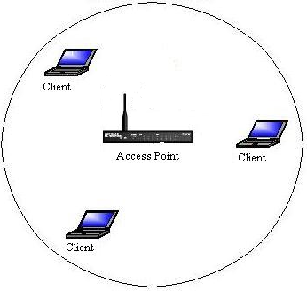
Figure 1: Basic Service Set

The Temporal Key Integrity Protocol (TKIP) encryption algorithm was created to provide stronger security than WEP. TKIP encrypts the layer 2 payload located after the packet header. Network devices can read the unencrypted packet header and forward it as it would any other packet. In addition, a Message Integrity Check (MIC) is used to check whether data has been tampered with. TKIP is used with WPA security. Its key length is 128 bits long.
The IEEE 802.11i standard recommends the use of Advanced Encryption Standard (AES) encryption. AES uses additional data from the MAC header. This allows the destination host to recognise if the non-encrypted bits have been tampered with. Additionally, a sequence number is added to the encrypted data header. AES is used with WPA2 security. AES offers three different key lengths: 128 bit, 192 bit and 256 bit.
Wireless signals propagating through the air lose strength as the range increases. This is signal attenuation. Obstacles, such as walls, doors, windows, etc., and RF interference, such as that caused by cordless phones in the 2.4GHz frequency, increase signal attenuation. It affects the ability of the receiver to decode the signal. When signal power decreases to relatively low levels the receiver will most likely encounter bit errors when decoding the signal. This means that the receiver does not send an acknowledgement to the sender. After a short period of time the sender will retransmit possibly at a lower data rate to extend the range of the transmission. Excessive signal attenuation results in decreased network throughput due to the retransmission of data and lower data rates. (Geier, 2002)

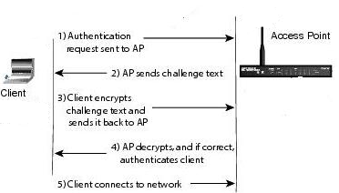

Figure 2: WEP authentication

A.2 Video on Demand
VoD is the real-time display of video allowing its users to view any video whenever they wish. A typical video stream consists of frames of pictures, audio and captioned text. As with a DVD player, VoD users can pause video, jump forward, jump backward, etc. However, VoD has yet to replace DVD rentals and purchases due to latency issues and insufficient network bandwidth.
A large quantity of data needs to be continuously transmitted with minimal delay. Video is delay sensitive and cannot tolerate jitter. Jitter is the variation of delay for data packets that are part of the same data traffic flow. Network delay is the transit time from the one device to another on the network. VoD needs to receive packets at a fairly constant rate with fixed delay between consecutive packets. As the arrival rate varies the jitter impacts the video quality. A minimal amount of jitter may be acceptable but as jitter increases the video may become “unwatchable”. As a result, the network needs high bandwidth with minimal delay and a low error rate as retransmission is unacceptable. (Ko, 1996)
VoD requires the network to be responsive when a user selects a video so that the user does not have to wait too long before it starts to play. The network also needs to be responsive during playback so the user can jump forward or backward or pause the video.
The generic architecture of a VoD system (see figure 3, page 4) comprises of the network provider, the program provider, the service provider, and the user. (Li et al, 1996)
VoD systems typically use multicast or broadcast schemes. A multicast scheme shares the same stream of data for video delivery as much as possible. A multicast scheme can provide immediate service and save server bandwidth by avoiding unnecessary transmission of data. However, it is susceptible to data loss and cannot guarantee on time delivery of data if user requests are too high. (Hu, 2001)
Broadcasting schemes address the problem of data loss by dividing a video into a number of segments and broadcasting each segment periodically on dedicated server channels. This guarantees service latency within certain amount of time. Whilst a video segment is playing the next segment is downloaded so that the whole video is viewed continuously. However, the viewer does have to wait for the first segment to be downloaded before playing the video. Since user cannot watch the video immediately, a broadcasting scheme does not provide true VoD service. (Hu, 2001)
A typical VoD network can be divided into two levels: the backbone and the local distribution network. The backbone connects the servers and routers/ access nodes together. The local distribution network links a client site to its nearby router/ access node. (Ko, 1996) For this investigation the local distribution network will be the BBS. The backbone will be the Internet accessed via the wired network that the AP connects to.

A.3 Performance Measurement
As this investigation will be determining the suitability of 802.11n to deliver VoD a means of assessing its performance is required. In order to measure the WLAN’s performance, it will be necessary to determine its baseline network performance first. This will accomplished by measuring bandwidth utilisation, network accuracy, network efficiency and delay and response time.
Bandwidth utilisation measures how much bandwidth is in use during a specific time interval. Thus, the percentage of capacity used can be calculated. The bandwidth utilisation can be measured using a protocol analyzer or Remote MONitoring (RMON) probe. A protocol analyzer is a fault and performance management tool that captures network traffic and provides statistics. The relative usage and absolute usage can be calculated. Network accuracy measures the Bit Error Rate (BER) using a BER tester. Network efficiency can be measured using a protocol analyser to examine the current frame sizes. A large number of “runt” frames signifies a high number of collisions resulting from access contention. The delay and response time can be measured by sending ping packets and noting the Round-Trip Time (RTT).
There are four primary metrics for capturing the quality of a wireless link: Received Signal Strength Indication (RSSI), Signal-to-Interference-plus-Noise Ratio (SINR), Packet-Delivery Ratio (PDR) and BER. (Vlavianos et al., 2008)

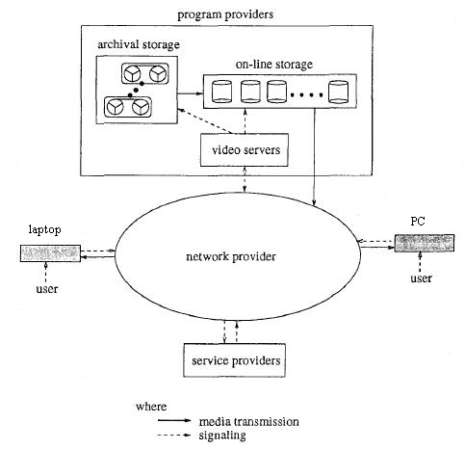

Figure 3: The generic VoD architecture (Li et al, 1996)

B. Examples and Critique of Current Research in the Field

B.1 VoD delivery over WLANs
Research conducted into VoD previously has studied VoD systems, broadcasting protocols for VoD, developing a performance model for VoD systems and whether a WLAN can be used as the final hop in VoD delivery. The investigation conducted by Furini et al. (2004) researched the suitability of 802.11g to deliver VoD by studying the affect of signal strength and traffic load. It concluded that 802.11g is suitable if the video server is located in the WLAN and the WLAN traffic load is low. The research was conducted in 2004 when the WLAN standards available were 802.11a/ b/ g. Technology has advanced with the IEEE standard 802.11n being ratified in 2009. Compared with 802.11g, the 802.11n standard provides faster data rates and thus, faster application speeds. This investigation aims to see whether an 802.11n WLAN can support VoD when the video server is located on the Internet and when traffic load is high.
The research conducted by Furini et al. (2004) used MPEG 1 videos encoded with bit rates of 240 kbps, 480 kbps, 768 kbps, 1000 kbps and 1500 kbps. Since 2004, the use of HD video has increased. As a result, this investigation will use HD video for its experiments. BBC iPlayer offers HD video encoding at least 1280 x 720 resolution (720 pixels (p)) with a bit rate of 3200 kbps and 192 kbps audio. The higher quality video will require more bandwidth. Furini et al. (2004) found that the quality of video encoded at 240 kbps, 480 kbps and 768 kbps were “acceptable” from a program provider on the Internet as the delay was less than 400 milliseconds (ms). However, videos encoded at bit rates 1000 kbps and 1500 kbps were “unacceptable” as the delay was greater than 400 ms and noticeable to the viewer.

B.2 Impact of signal strength on WLANs
It is commonly believed that the lower the signal strength the lower the wireless throughput and the stronger the signal the greater the throughput. Wireless networks have a high BER compared to wired networks. The BER varies due to environment of geographical conditions, such as RF interference and physical obstacles, such as walls and doors.
The investigation conducted by Furini et al. (2004) found that weak signal strength greatly increased packet loss and network delay. During the experiments conducted with weak signal strength the packet loss increased up to 20% and the average RTT increased. The results from the experiments testing strong signal strength showed packet loss of 0.5% and a delay of 150 ms. The average RTT ranged from 20 ms (when playing video with a bit rate of 240 kbps) to 60 ms (when playing video with a bit rate of 1500 kbps).
This investigation will be using video encoded at 3200 kbps which is a greater bit rate than used in the research by Furini et al. (2004) The results of experiments testing different signal strengths (“low”, “good”, “very good” and “excellent”) are expected to similarly show that the packet loss and network delay increases as the signal strength decreases.

B.4 Impact of traffic load on WLANs
The research conducted by Furini et al. concluded that 802.11g could support VoD when the traffic load is low. However, it found that high traffic load had the greatest affect on video quality (compared to signal strength). In each experiment conducted with high traffic load each video, although encoded at different bit rates, was “unacceptable”. The research concluded that the WLAN was not able to support VoD as the delay was too great.
As this investigation will use the 802.11n standard which uses the MIMO technology the results are expected to differ. The results of the traffic load experiments are likely to provide the most interesting results as video cannot tolerate delay and Furini et al. (2004) found that traffic load affected the delay the greatest.

B.4 Impact of security on WLANs
It is commonly believed that the greater the security mechanism used the greater the overhead. The shorter the key used for security mechanism, the quicker it is to break. Therefore, the longer the key the longer it will take to break it. However, the shorter the key the quicker it is for a network node to pass the data.
Research into the impact of security on VoD delivery over WLANs has not been conducted. However, research into the impact of security mechanisms on WLAN throughput has. Research by Barka and Boulmalf (2007) reported significant degradation when using security mechanisms. The results for overhead were between 7% when using WEP and 25% when using WPA for a 1500 byte data field.
In contrast, research by Potorac and Balan (2009) found the security overhead was less than Barka and Boulmalf’s (2007) research results. The research conducted by Potorac and Balan (2009) on WEP security found the overhead insignificant for large packets but the overhead larger for small packets. WEP encryption uses 8 bytes. For a 1500 bytes data field the WEP efficiency is 1500/(1500+8) = 99.46%, or 0.54% degradation. However, for a 10 byte data field the efficiency greatly decreases to 55.5%. The research findings of McCarter (2006), Agarwal et al. (2004) and Kamran et al. (2003) closely match the conclusions of the research conducted by Potorac and Balan (2009).
The research conducted by Potorac and Balan (2009) studied WEP and WPA but did not study WPA2. However, McCarter (2006) researched WEP (with 40 bit and 128 bit keys), WPA and WPA2. The results from this research concluded that WPA has the greater overhead of the security mechanisms tested. WPA2 was only slightly less efficient than WEP. The average overhead results were 2.89% for WPA2, 3.67% for WPA, 1.76% for WEP (128 bit) and 1.71% for WEP (40 bit). As the IEEE 802.11i standard recommends the use of WPA2 the results of its security overhead indicate that throughput will not be significantly affected.
This investigation aims to see if the overhead of WEP, WPA and WPA2 greatly affect the quality of video. If there is a significant impact of security mechanism on the WLAN the quality of video played in the experiments will be “unacceptable”. As previous research has not considered the affect of security on VoD delivery over WLANs new information will be provided.

PILOT RESEARCH STUDY

Hypothesis
The aim of this investigation is to determine whether 802.11n can deliver VoD. This will be accomplished by testing the effect of signal strength, security and traffic load on VoD delivery over an 802.11n network. Thus, this investigation will determine if there is a correlation between the following:

- Signal strength and quality of video
- Level of security and quality of video
- Traffic load and quality of video

The hypothesis is that there is a correlation. Results of the investigation are expected to show the following:

- The lower the signal strength the greater the reduction in the quality of video.
- The greater the security used the greater the reduction in the quality of video.
- The higher the traffic load on the WLAN the greater the reduction in quality in video.

Research Method
A series of experiments will be conducted to test the impact of signal strength, security and traffic load on the quality of video played. To build a VoD system will be time-consuming and difficult with limited resources. As a result, the BBC iPlayer will be used as the VoD program provider. The BBC iPlayer has been selected as it is easily accessible, free to use and designed to work on any computer in the UK. There are numerous available videos that can be used in the experiments available via the BBC iPlayer website. BBC iPlayer offers video streaming and downloading for video. The experiments will be conducted using video streaming. To use BBC iPlayer’s video streaming the user selects “click to play”. (See figure 4, page 5.) The BBC iPlayer allows users to select to play HD or normal quality video. Each experiment will use HD video for improved sound and video quality.
Each experiment testing the impact of signal strength (“low”, “good”, “very good” and “excellent”), impact of security (Open, WEP, WPA and WPA2) and traffic load (“low”, “medium” and “high”) will involve watching the same video at the same time of day. This will help to eliminate outside factors affecting the delivery of VoD on the backbone, such as Internet traffic, utilisation of the BBC iPlayer website, etc.

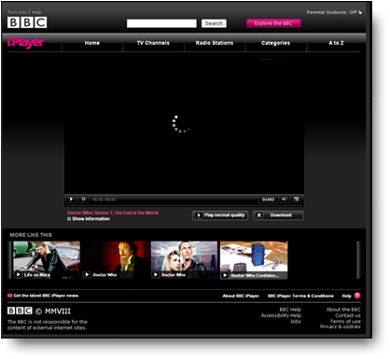
Figure 4: BBC iPlayer (BBC, 2010)

The suitability of 802.11n to deliver VoD will be determined by the quality of video in the experiments conducted. Poor service will be indicated by the video pausing and a circle spinning on the BBC iPlayer screen. Additionally, statistics will be collected to measure the performance of the WLAN. The statistics collected will be used to measure the bandwidth utilisation, network efficiency, and delay and response time. The delay and response time variance measurements are important for video as it cannot tolerate jitter.
In order to conduct the investigation it will be necessary to develop a baseline network performance for the WLAN. The baseline will be determined by copying of a file from one laptop to another using the AP.
The measurements taken during each of the experiments will be used in quantitative data analysis. The analysis of the results will be used to prove, or disprove, the hypothesis that there is a correlation between signal strength and quality of video, level of security and quality of video and traffic load and quality of video.

Initial Results
Research conducted previously into the suitability of WLANs to deliver VoD focused on the 802.11g standard. The investigation conducted by Furini et al. researched how signal strength and traffic load affected the suitability of 802.11g to deliver VoD. The conclusion of the investigation was that 802.11g can support VoD if the video server is located within the WLAN and if the WLAN traffic load is low. If the WLAN traffic load was high or if the video server was accessed across the Internet the quality of video was poor. (Furini et al., 2004)
The data rates achievable by 802.11n are greater than 802.11g. Theoretically, 802.11n can achieve up to 600 Mbps compared to 54 Mbps that 802.11g can achieve. (Wi-Fi, 2010) As a result, the findings of this investigation are expected to differ.
The investigation conducted by Furini et al. did not consider the affect of security on VoD delivery nor did it study the affect of different AP configuration settings. However, this investigation will study the affect of security and AP settings on the deliver of VoD. As a result the investigation will provide new information for VoD system developers.

OUTLINE OF PROPOSAL

Aims of the Investigation
An investigation will be conducted into VoD delivery over WLANs. The aim of this investigation is to discover whether the IEEE standard 802.11n is suitable for the delivery of VoD. To assess the suitability of 802.11n the impact of signal strength, security and traffic load will be considered. The security mechanisms investigated will be Open, WEP, WPA and WPA2. Experiments will also be conducted to investigate fine tuning the AP’s configuration to see the effect of different network modes, radio bands, wide channel and standard channel settings on performance.

Research Objectives
The investigation will determine the impact of signal strength, security and traffic load on VoD delivery over 802.11n. Additionally, the impact of an AP configuration settings for network modes, radio bands, wide channel and standard channel settings will be investigated. The following questions will be answered as part of the investigation:

- How does the security implemented on the AP and client impact the quality of video viewed?

- What is the effect on the quality of video when Open security is used?
- What is the effect on the quality of video when WEP security is used?
- What is the effect on the quality of video when WPA security is used?
- What is the effect on the quality of video when WPA2 security is used?

- How does the signal strength between the client and the AP impact the quality of video viewed?

- What is the effect on the quality of video when the signal strength is “excellent”?
- What is the effect on the quality of video when the signal strength is “very good”?
- What is the effect on the quality of video when the signal strength is “good”?
- What is the effect on the quality of video when the signal strength is “low”?

- How does the WLAN’s traffic load impact the quality of video viewed?

- What is the effect on the quality of video when the traffic load is “high”?
- What is the effect on the quality of video when the traffic load is “medium”?
- What is the effect on the quality of video when the traffic load is “low”?

- How does fine-tuning the AP’s configuration settings affect the quality of video viewed?

- Does the setting for network mode have an effect on the quality of video?
- Does the setting for radio band have an effect on the quality of video?
- Does the wide channel setting have an effect on the quality of video?
- Does the standard channel setting have an effect on the quality of video?

The results of this investigation will determine the suitability of 802.11n for delivering VoD.

C. Methodologies
The hypothesis states that there is a correlation between the signal strength and the quality of video, the level of security and the quality of video and the traffic load and the quality of video. This hypothesis will be tested by conducting a series of experiments testing the impact of signal strength, security, traffic load and AP configuration settings on the quality of video viewed. The results of these experiments will answer the questions posed in the Research Objectives and determine whether 802.11n is suitable for delivering VoD.
This investigation will take the form of positivistic research. As the research tests a hypothesis, it will use quantitative data analysis. The analysis of the results

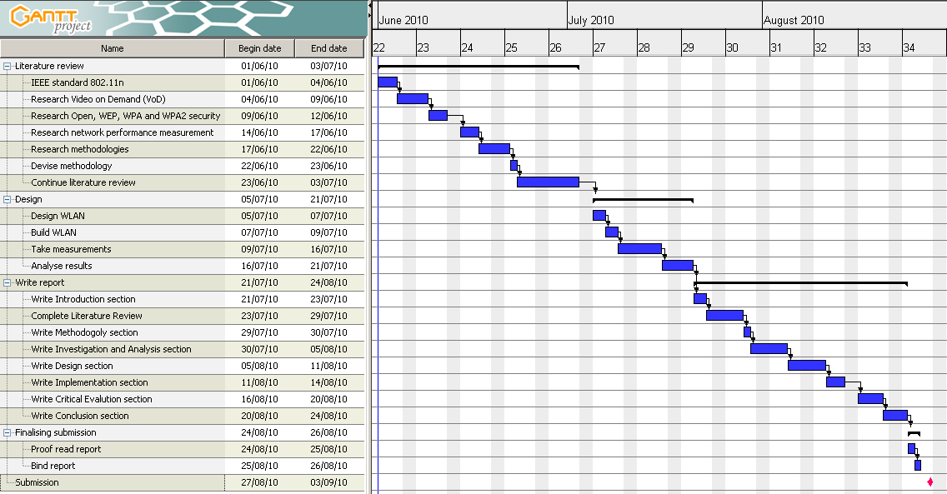

Figure 5: Timetable

collected will prove, or disprove, the hypothesis. The investigation will be descriptive research that aims to discover the suitability of 802.11n to delivery VoD. The suitability will be determined by investigating the impact of signal strength, security and traffic load on VoD delivery. If the quality of video is “acceptable” under each experiment 802.11n will be deemed suitable for VoD delivery. If the quality of video is “unacceptable” 802.11n will be deemed unsuitable.

Ethical Considerations
There will be no human participants involved in the experiments and research. No confidential data will be stored or accessed as part of the research. The video that will be used in the experiments will be accessed from the BBC iPlayer website and thus will not break any copyright laws. The BBC iPlayer terms and conditions of use will be observed during all experiments. (For the terms and conditions see http://www.bbc.co.uk/iplayer.) The equipment that will used to build the WLAN and the Internet access will be used with the permission of the owner(s).

Plan and Timetable
The investigation will commence the beginning of June and reach completion by September. The investigation has been divided into sections which have been sub-divided into tasks (see figure 5). Each task will be completed in order and has been allocated a duration time to ensure that the investigation is completed by the submission deadline (indicated by the red milestone). To allow for unforeseen circumstances a period of time before the submission deadline has been left unallocated.

Limitations and Scope
The investigation will focus on the IEEE standard 802.11n. As a result, 802.11n equipment will be used in all experiments.
The impact of signal strength on VoD delivery over 802.11n will be investigated. However, this investigation will not be considering the appropriate placement of APs. Additionally, it will not be considering factors such as the attenuation from obstructions or RF interference. In order to eliminate these factors from influencing the result, each experiment will be conducted under the same conditions. The AP will be in the same place for each experiment.
The impact of security on VoD delivery over 802.11n will be investigated. However, this investigation does not aim to recommend what security mechanism should be implemented on a WLAN.
Quality of Service (QoS) is beyond the scope of this investigation.

Personal Development Requirements
A literature review will be conducted using the University Library, journals and Internet resources to increase knowledge of the research area. The literature review to be conducted will focus on the following areas:

- IEEE standard 802.11n
- VoD
- Open, WEP, WPA and WPA2 security
- Network performance measurement
- Positivistic research methodologies
- Quantitative data analysis
- Selection of a tool to measure signal strength
- Selection of a protocol analyser
- Selection of a BER tester
- Selection of a time management tool

Resource Requirements
In order to conduct the experiments outlined for this investigation, the following hardware requirements will need to be met:

- 1 x 802.11n AP
- 2 x 802.11n Wireless Network Interface Cards (WNICs)
- 2 x Windows XP laptops; one of the laptops needs to meets the minimum requirements for the BBC iPlayer
- Internet access via a wired LAN

The following lists the software requirements for the experiments:

- BBC iPlayer
- Tool for measuring signal strength
- Protocol analyser
- BER tester

Additional requirements in order to conduct the investigation include the following:

- Microsoft Word
- Microsoft Excel
- A PC with Internet access and browser
- Time management tool
- Library books

Initial research has discovered that the BBC iPlayer is available for download from the BBC website for free. There is a Windows version of the software which means that the software can be installed on a Windows XP laptop to be used in the experiments. The BBC iPlayer will work with Windows, Macintosh, Linux or other Operating Systems (OS). The requirements for BBC iPlayer are as follows:

- Adobe Flash Player
- Access the BBC iPlayer website
- Internet connection speed of at least 3.2 Mbps (for HD video)

Research into Adobe Flash Player determined version 10 to be the latest version. Adobe Flash Player 10 has the following minimum system requirements for the Windows XP OS:

- Intel® Pentium® II 450 MegaHertz (MHz), AMD Athlon™ 600 MHz or faster processor (or equivalent)
- 128 Megabit (Mb) Random Access Memory (RAM)
- Microsoft Internet Explorer 6.0 or later, Firefox 2.x or later, AOL 9, Opera 9.5 or later, Safari 3.x, Chrome 2.0 or higher

The minimum requirements for the Windows OS HD playback at 1,280 x 720 resolution, 720 p, 24–30 fps) are as follows:

- Intel Pentium 4 3GHz, AMD Athlon™ 64 3400+ processor (or equivalent)
- 128 Mb RAM
- 64 Mb VRAM

The tool for measuring the signal strength will to be decided during the literature review.
Research discovered the following protocol analysers:

- The Sniff Network Analyzer from Network Associates
- EtherPeek from WildPackets
- Ethereal

Ethereal will be used as it is a free open source package and has a windows version. The software is available for download from the Ethereal website.
The requirement for Microsoft Word needs to be met in order to document the investigation. Microsoft Word has been selected as the researcher is familiar with the application and a PC with Microsoft Word installed is available for use.
The requirement for Microsoft Excel needs to be met in order to conduct the quantitative data analysis. Microsoft Excel has been selected as the researcher is familiar with the application and a PC with Microsoft Excel installed is available for use.
A PC with Internet access and browser is a requirement to complete the literature review. As it is important to find the most up-to-date information the Internet will be primarily used. A PC with Internet access and a browser installed (that the researcher is familiar with) is available for use.
An initial literature review to find a time management tool was conducted. Microsoft Project was considered as it is installed on the University’s Library PCs. Although the PCs are available to students of the University they are not always accessible. However, using the Google search engine (http://www.Google.co.uk) freeware and shareware applications were found. The requirements were an application that can create Gantt charts and that be installed on an accessible PC. Shareware software was dismissed. Software that worked online and was not installed locally on a PC was dismissed. GanttProject 2.0.10 was chosen as it is freeware, installed locally on a PC and can produce Gantt charts. A PC with GanttProject installed is available for use.
The University Library will be used for materials as part of the literature review. Initial research has ascertained the opening hours and book lending policies.
References
- Carmichael, S (2010) The next step in in-flight Wi-Fi - video on demand in the skies. Available at: http://www.gadling.com/2010/01/10/the-next-step-in-in-flight-wi-fi-video-on-demand-in-the-skies [Accessed January 10, 2010].
- Whitney, L (2009) Ford cars to become Wi-Fi hotspots. Available at: http://news.cnet.com/8301-1035_3-10419548-94.html [Accessed January 10, 2010].
- Cisco, Network Academy, LAN Switching and Wireless. Available at: http://cisco.netacad.net [Accessed December 30, 2009].
- Furini, M., Ghini, V., Roccetti, M (2004) Interactive Video Streaming over Wi-Fi Networks: An Experimental Assessment, Department of Computer Science, University of Piemonte Orientale, Italy.
- Geier, J (2002) Beating Signal Loss in WLANs. Available at: http://www.wi-fiplanet.com/tutorials/article.php/1431101 [Accessed February 15, 2010].
- Ko, M., Koo, I (1996) An Overview of Interactive Video On Demand System. The University of British Columbia.
- Li, V.O.K.., Laio,W., Qiu, X and Wong E.W.M. (1996) Performance Model of Interactive Video-on-Demand Systems, IEEE Journal Areas in Communications, Volume 14, No. 6, p1100.
- Hu, A (2001) Video-on-Demand Broadcasting Protocols: A Comprehensive Study, Intel Corporation, p1.
- Vlavianos , A., Law, L.K., Broustis, I., Krishnamurthy, S.V., Faloutsos, M (2008) Assessing Link Quality in IEEE 802.11 Wireless Networks: Which is the Right Metric? Department of Computer Science and Engineering, University of California, USA.
- Barka, E., Boulmalf, M (2007) On The Impact of Security on the Performance of WLANs, Journal of Communication, Volume 2, No. 4.
- Potorac, A.D., Balan, D (2009) The Impact of Security Overheads on 802.11 WLAN Throughput, Faculty of Electrical Engineering and Compter Science, University of Suceava, Romania.
- McCarter, H (2006) Analyzing Wireless LAN Security Overhead, Faculty of Electrical Engineering, Virginia Polytechnic Institute and State University, USA.
- Agarwal, A.K., Gill, J.S., Wang W (2004) An experimental study on wireless security protocols over mobile IP networks, IEEE Vehicular Technology Conference, Volume 7, p. 5271 – 5275.
- Kamran, J., Liyu, Y., Hamza, M.H. (2003) Performance Evaluation of Technologies for Security 802.11 Enterprise Wireless Networks, CNIS 2003 Conference on Communication, Network, and Information Security, New York, USA.
- BBC iPlayer. Available at: http://www.bbc.co.uk/iplayer [Accessed January 22, 2010].
- Adobe Flash Player. Available at: http://www.adobe.com/flashplayer [Accessed January 22, 2010].
- Ethereal. Available at: http://www.ethereal.com [Accessed February 8, 2010].
- GanttProject. Available at: http://www.ganttproject.biz [Accessed December 15, 2009].

